CSA1509-Cloud computing and Big Data Analytics
Name : yuvan shankar L
Reg.no: 192511072

EXP 14 : Create a Virtual Hard Disk and allocate the storage using VM ware Workstation.
Aim:
To Create a Virtual Hard Disk and allocate the storage using VM ware Workstation.

Steps:
- Download VMware software and install it as Type-2 Hypervisor.
- Download Ubuntu or tiny os as ISO image file.
- In VMware workstation → Create new VM
- Do the configuration based on given conditions.
  - Add extra Hard disk and allocate Storage to it.
- Created a virtual Machine.
- Launch the VM.

Implementation:
- Download and open VMware software.
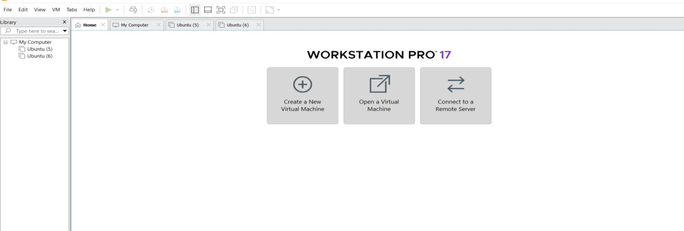

Create a new VM

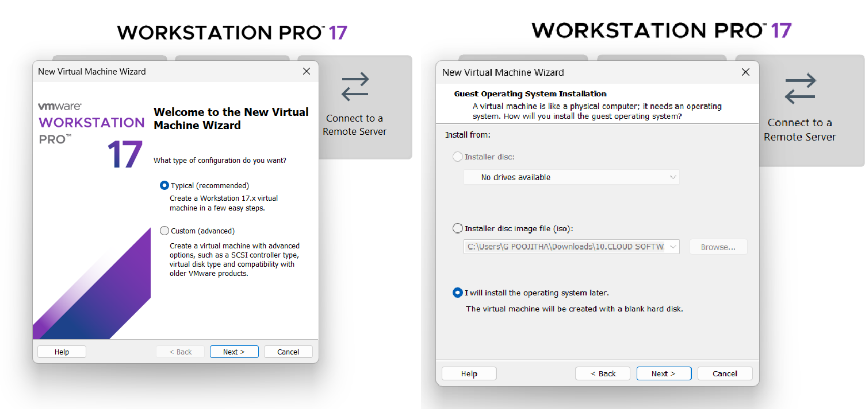
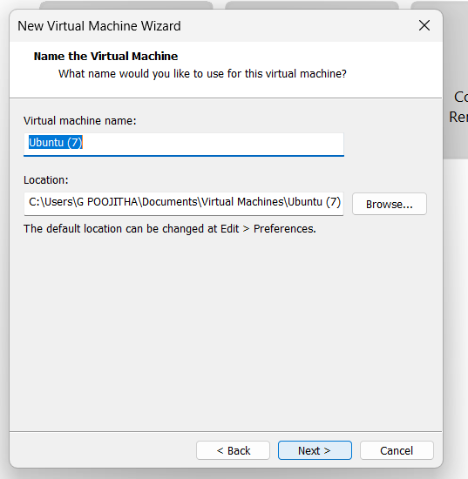
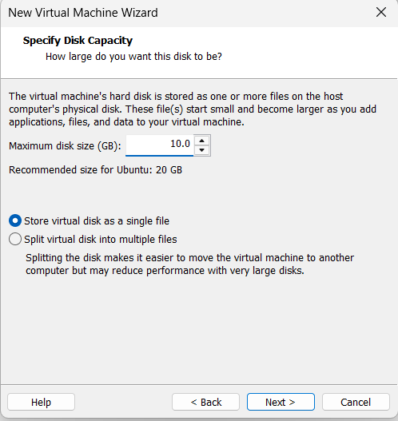

Name it anything→click on next→Adjust the size of disk → change the option to first and then click on next.
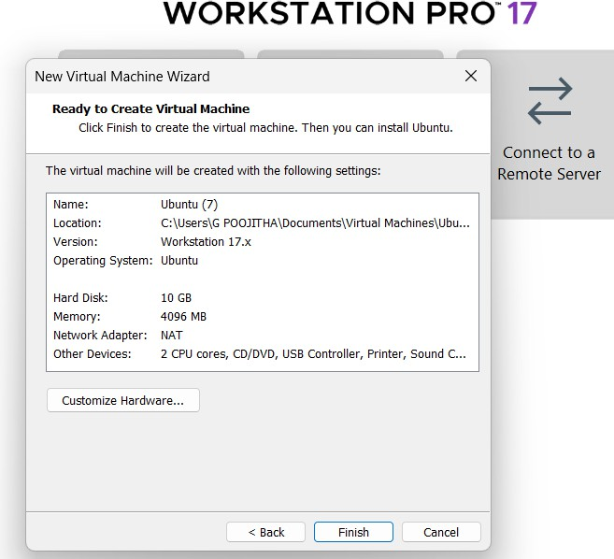
Click on Finish to Launch .

VM is created
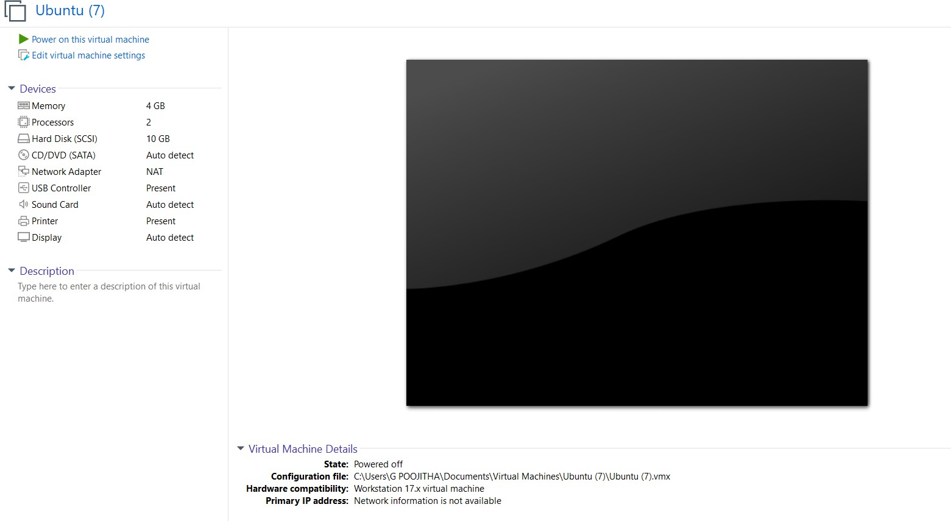

Double-click on Hard disk and Click on add and create a new Hard disk
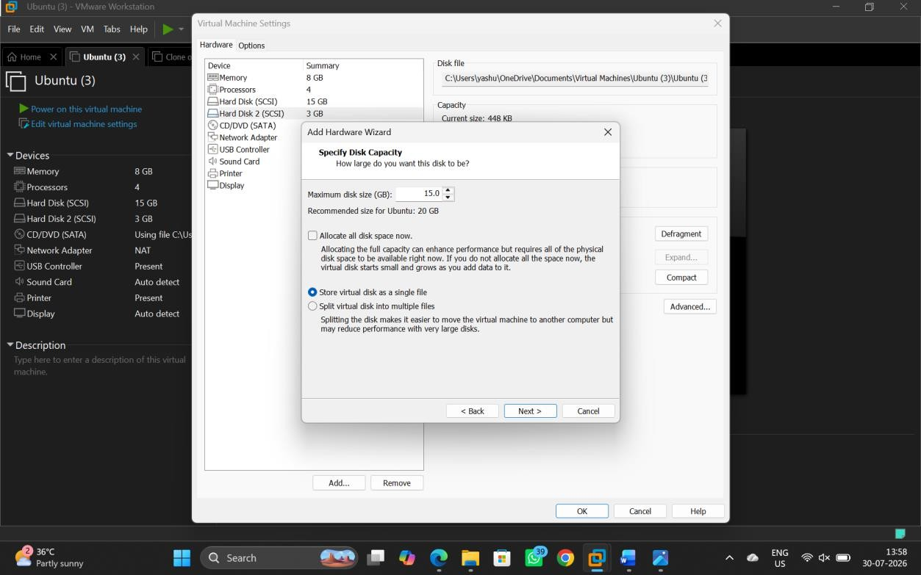

6. VM is created according to the conditions given.
